<page_start no = 1>
<sol_start id=1>
1. p(x) = x²–2x–(7p+3)
P(–4) = 16–2(–4)–(7P+3)
= 16 + 8–7P–3
O = 24–3–7P
= 21 –7P
7P = 21
P = 3
- 3
<sol_end>

<sol_start id=2>
2. (4) No solution
<sol_end>

<sol_start id=3>
3. Radius = OB
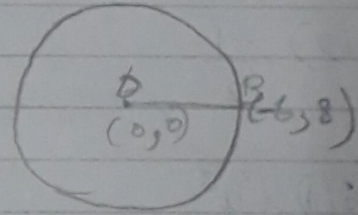
= 10 units
(1) 10 units
<sol_end>

<sol_start id=4>
4. (2) Proportional
<sol_end>

<sol_start id=5>
5.
= sin²30°–cos²30°
(2)
<sol_end>
<page_end>

<page_start no = 2>
<sol_start id=6>
6. (1) x³y³
<sol_end>

<sol_start id=7>
7. 4x²–2x+(k–4)
k–4 = 4
k = 4 + 4
= 8
<sol_end>

<sol_start id=8>
8. A(0, 0) ; B(3, ); c (3, x)
AB = BC = CA
;
;
;
is rejected
<sol_end>
<page_end>

<page_start no = 3>
<sol_start id=9>
9. 2 px + 3y =7
2x + y = 6
one solution
<sol_end>
<sol_start id=10>
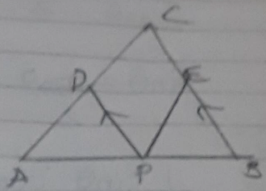
10. given
PD ̸ ̸ BC
To prove that
EP ̸ ̸ AC

Statement | Reason
PD ̸ ̸CB  (1)  (2)  From (1) and (2)  since  EP ̸ ̸ AC | Given  Basic proportionality  theorem  given  Converse of Basic Proportionality theorem

<sol_end>
<page_end>

<page_start no = 4>
<sol_start id=11>
11.
<sol_end>

<sol_start id=12>
12. 5⁴×2³ = 5000
n = 3
m = 4
= 0.0514
<sol_end>

<sol_start id=13>
13. assume = is rational.
(a and b are coprime)
3b² = a²
a = 3C …..(1)
(3c)² = 3b²
…..(2)
b is divisible by 3
Since a and b are divisible by 3.
They are not co-prime. Hence .
an irrational number.
<sol_end>

<sol_start id=14>
14. p(x) = 2x² – 3x + 7
= –3/28
3x – (a + 1)y –(2b–1)
5x + (1–2a)y – 3b
infinitely many solutions.
–5(a+1)=3 (1–2a)
–5a –5 = 3–ba
–5a + ba = 3+5
a = 8
5(2b–1) = 3(3b)
10b–5 = 9b
10b–9b = 5
b = 5
<sol_end>

<sol_start id=16>
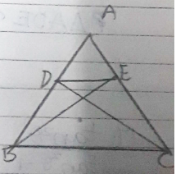
16. Given
To prove that

Statement | Reason
DE ̸ ̸ BC | Basic proportionality theorem  Common angle  By SAS similarity criteria.
<sol_end>

<sol_start id=17>
17. +

LHS = RHS
<sol_end>
<page_end>

<page_start no = 5>
<sol_start id=18>
18. 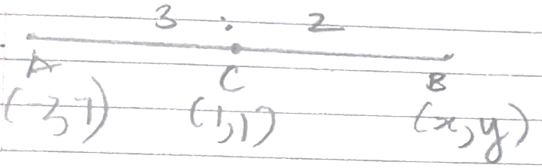
<sol_end>

<sol_start id=19>
19.
2x = y+1
2x–y = 1 …(1)
x–y = –4 …(2)
x = 5
–y = –4 –5
= –9
y = 9
<sol_end>

<sol_start id=21>
21.
<sol_end>

<sol_start id=22>
22. A(1, 2); B(2, 3); C(6, 5); D(x, y)
AB = DC
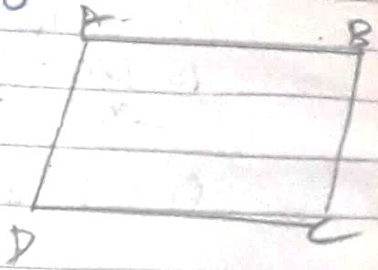
AD = BC
2 = x² + y² – 12x – 10y + 61
–59 = x² –12x + y²–10y …(1)
BC =

AD =
20 = x² – 2x + y² – 4y + 5 …(2)
15 = x²–2x+y²–4y
–59 = x2–12x+y²–10y
= x(x–12)+y(y–10)
–5+ = (x+y) ) (x–12)
x = 12 x = –y
x = 12
y = –12
<sol_end>
<page_end>

<page_start no = 6>
<sol_start id=23>
23. Circumference = 1980 m
A = 330 m/min
B = 198 m/min
C = 220 m/min

D 1980
HCF of 6, 10, 9
6, 10, 9
2
3, 5, 9
3
1, 5, 3
5
1, 1, 3
3
1, 1, 1
= 90 mins = They will meet after 90 mins at starting point.
<sol_end>

<sol_start id=24>
24. 2x + y = 70 y = Father
2y + x = 95 x = Son
3y = 120
y = 40
x = 15
Father = 40, Son = 15
<sol_end>
<page_end>

<page_start no = 7>
<sol_start id=26>
26. cosecθ–sinθ = m
secθ–cosθ = n
+
1 = 1
LHS = RHS
Hence proved
<sol_end>

<sol_start id=27>
<sub_id = 1>
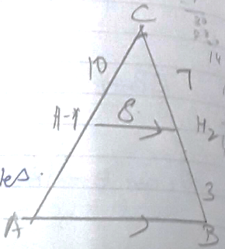
27. (ii) 4.26 miles
<sub_id end>
<sub_id = 2>
(iii) 18.2
<sub_id end>
<sub_id = 3>
(iv) Hotel B to mountain = 5 miles
3x + 7x = 5
10x = 5
<sub_id end>
<sol_end>

<sol_start id=28>
<sub_id = 1>
28. (ii) PR =
<sub_id end>
<sub_id = 2>
(iii) (3, 4)
= (5, 4)
<sub_id end>
<sol_end>
<page_end>

<page_start no = 8>
<sol_start id=30>
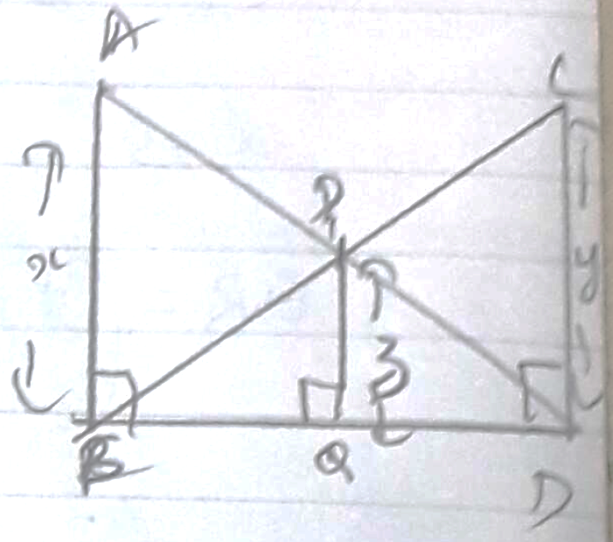
30. Given
To prove that

Statement | Reason
CD = CD (S)  AD = CB (H)  x= y | Given  Common side  RHS
<sol_end>
<page_end>

